Mrs Soulsby and Miss Barratt’s Recommended Reading List
If you are stuck for what to read next, try these ones out; they are perfect for Year 4! We have included some new ones as well as some golden oldies.
We also highly recommend www.lovereading4kids.co.uk as a brilliant search engine for finding your new favourite book!
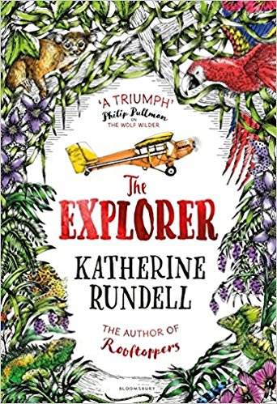
Desirable, Frank Cottrell Boyce
My Brother is a Superhero, David Solomons
There’s a Werewolf in my Tent, Pamela Butchart
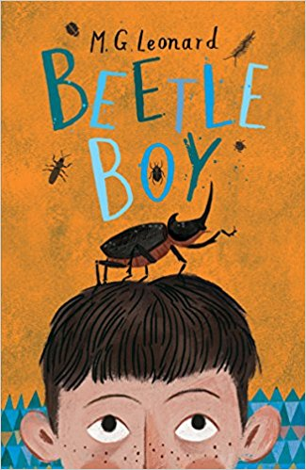
The 13 Storey Treehouse, Andy Griffiths
Frank Einstein and the Antimatter Motor, Jon Scieszka
Krindlekrax, Philip Ridley (Loved by 4S!)
Operation Gadgetman, Malorie Blackman
The Explorer, Katherine Rundell (Mrs Soulsby’s favourite!)
Ultimate Football Heroes, Tom and Matt Oldfield (There are a whole series of these!)
The Wizards of Once, Cressida Cowell
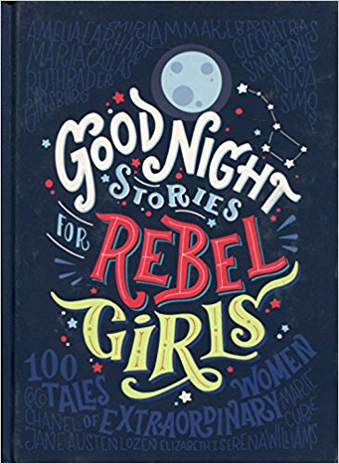
Toad Rage, Morris Gleitzman
Stories for Boys of Dare to be Different, Ben Brooks
Bottersnikes and Gumbles, S A Wakefield (Mrs Barratt’s favourite!)
The Falcon’s Malteser, Anthony Horowitz
The Worst Witch, Jill Murphy
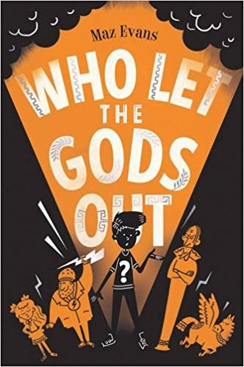
The Suitcase Kid, Jaqueline Wilson
Goodnight Stories for Rebel Girls, Elena Favilli
The Parents Agency, David Baddiel (Loved by 4B!)
For more able readers
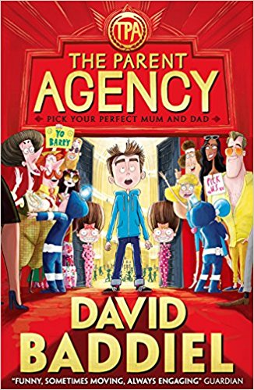
Who Let the Gods Out, Maz Evans
Beetle Boy, MG Leonard
The Wolf Wilder, Katherine Rundell
Brightstorm, Vashti Hardy
King of the Cloud Forests, Michael Mopurgo
The Miraculous Journey of Edward Tulane, Kate DiCamillo

