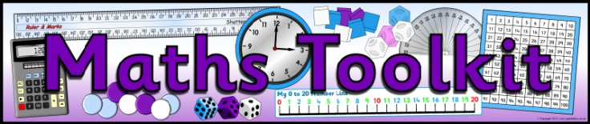

Column addition
th H T O
6 4 8
3 7 2 +
1 0 2 0
1 1

O . 10th 100th
£ 3 . 2 9
£ 1 . 3 6 +
£ 4 . 6 5
1

Line up the place value and the decimal point!
‘Carry’ if your answer is bigger than 9

Colum Subtraction
Biggest number on top, line up the place value and the decimal point!
8
1
th H T O
6 9 8
3 7 9 -
3 1 9

2
1
O . 10th 100th
£ 3 . 2 9
£ 1 . 6 6 -
£ 1 . 6 3

‘Borrow’ if the top number is smaller than the bottom number

Number line subtraction (working out change)
£10.00 - £2.76= £7.24
£10

£3.00

£2.80

£2.76

£7.00

20p

4p

Formal multiplication
H T O
2 8
8 x
2 2 4
6

Line up the place value!
‘Carry’ if your answer is bigger than 9

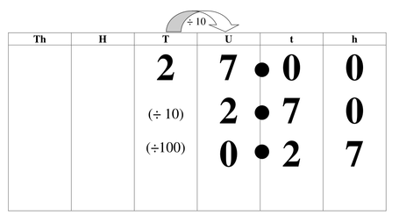
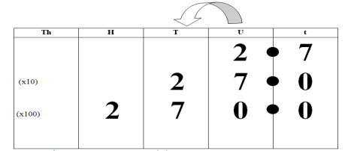
Multiply / divide by 10, 100, 1000
Cha-cha slide the numbers through the place value chart

27 ÷ 10 = 2.7
27 ÷ 100= 0.27

2.7 x 10 = 27
2.7 x 100= 270

